Practical - 1
Practical Title: Project Initiation, Requirement Analysis, Sitemap, Wireframe, and GitHub Setup

Problem Definition: Initiate the semester-long StudentHub portal by identifying the problem scope, user roles, key modules, navigation flow, and minimum 10 pages. Create a sitemap, low-fidelity wireframe, project folder structure, README file, and GitHub repository.

A. Theory

1. What is URL and parts of URL?
Answer: URL (uniform resource locator) is the web address used to access a webpage or resource on the internet.
A URL begins with a protocol such as http:// or https://.
It contains a domain name, which identifies the website (e.g., www.google.com).
It may also include a path, query parameters, and a fragment to locate a specific page or section.
Example: https://www.example.com/about?user=1#contact where https is the protocol, www.example.com is the domain, /about is the path, ?user=1 is the query, and #contact is the fragment.

2. How does HTML file process in web browser?
Answer: The browser reads the HTML file after it is opened or downloaded from a web server.
- It parses the HTML code and creates a DOM (Document Object Model).
- The browser loads linked CSS files to style the webpage and JavaScript files to add interactivity.
- It combines the HTML, CSS, and JavaScript to build the page layout.
- Finally, the browser renders and displays the complete webpage on the screen

3. How will page navigation flow managed among all HTML pages?
1. Answer: Page navigation is managed using HTML <a> (anchor) tags with the href attribute.
2. Each page contains links to other pages such as Home, Login, Courses, and Contact.
3. Clicking a link opens the corresponding HTML page in the browser.
4. A common navigation bar is used on all pages for consistent navigation.
5. This ensures users can easily move between all pages of the website.

4. How will GitHub commits be maintained after each practical?
- Answer: A GitHub commit will be created after completing each practical or major task.
- Each commit will have a clear and meaningful message describing the changes made.
- The updated project will be pushed to the GitHub repository regularly.
- This helps track progress and maintain version history of the project.
- If needed, previous versions can be restored using GitHub's commit history.

B. Implementation/ Output/Result :
Sitemap:
StudentHub Portal

│
├── Home
│
├── Login
│
├── Register
│
├── Dashboard
│ ├── Profile
│ ├── Courses
│ ├── Attendance
│ ├── Assignments
│ ├── Results
│ ├── Timetable
│ ├── Study Material
│ ├── Fees
│ ├── Notices
│ ├── Contact
│ └── Logout
Project folder structure:
StudentHub/
│
├── index.html # Home page
├── README.md # Project description
│
├── pages/
│ ├── login.html
│ ├── register.html
│ ├── dashboard.html
│ ├── profile.html
│ ├── courses.html
│ ├── attendance.html
│ ├── assignment.html
│ ├── result.html
│ └── contact.html
│
├── css/
│ └── style.css # Stylesheet
│
├── js/
│ └── script.js # JavaScript
│
├── images/
│ ├── logo.png
│ ├── student.png
│ └── banner.jpg
│
└── assets/
├── icons/
└── documents/
Wireframe:
We create wireframe using drawio

C. Evidence of Work (Screenshots)
Wireframe:
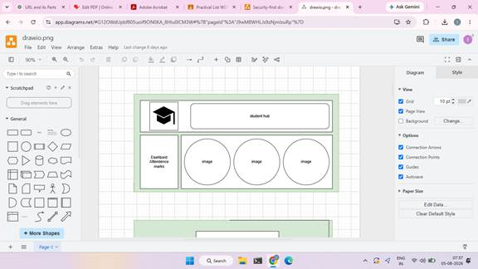
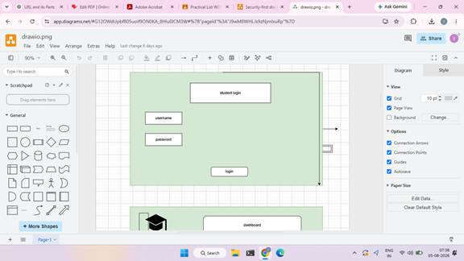
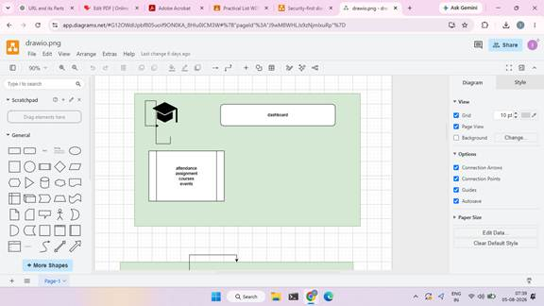
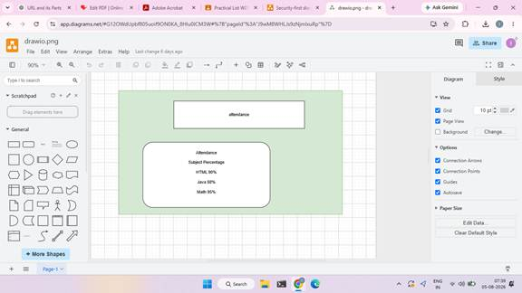
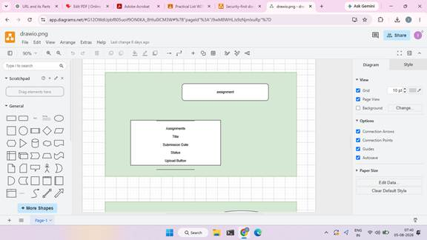
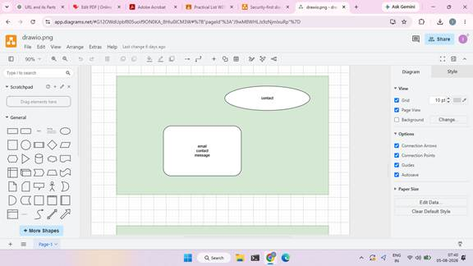
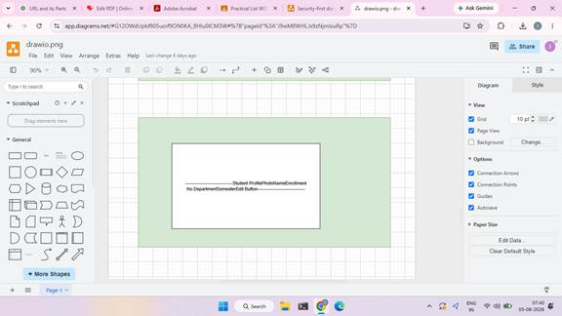

D. GitHub Repository Link: https://github.com/25dce049-ui

E. Challenges Faced:
Understanding the project requirements and planning the StudentHub portal.
Creating a proper sitemap and wireframe for all 10 pages.
Organizing the project folder structure correctly.
Linking all HTML pages and ensuring smooth navigation.
Setting up Git, creating a GitHub repository, and uploading the project successfully.

F. Learning Outcomes:
Learned how to analyze project requirements and define the scope of a web application. Understood how to create a sitemap and low-fidelity wireframes for website planning.
Gained knowledge of organizing a project using a proper folder structure.
Learned to create and connect multiple HTML pages through navigation links.
Understood how to use Git and GitHub for version control and project management.

Faculty Remarks: (Keep this blank for faculty)

